An SSH key is an alternate way to identify that doesn't require to enter an username and password every time.

Checking if existing key SSH keys are present.

zeus@zeus-VirtualBox:~/Documents/GitHub/InformationSystems$ ls -la ~/.ssh/

total 8

drwx------ 2 zeus zeus 4096 oct 23 18:41 .

drwxr-xr-x 35 zeus zeus 4096 dic 22 23:21 ..

The directory is empty, if a key had been in it, it looked like : id_ed****.pub the public key and id_ed*** the private key)).

Generate a new key pair using a [email@email.com](mailto:email@email.com). If there had already been one private key, and it is tried to generate another one, it asks whether it should overwrite.

zeus@zeus-VirtualBox:~/Documents/GitHub/InformationSystems$ ssh-keygen -t ed25519 -C "raimbp@gmail.com"

Generating public/private ed25519 key pair.

Enter file in which to save the key (/home/zeus/.ssh/id_ed25519):

Enter passphrase (empty for no passphrase):

Enter same passphrase again:

Your identification has been saved in /home/zeus/.ssh/id_ed25519

Your public key has been saved in /home/zeus/.ssh/id_ed25519.pub

The key fingerprint is:

SHA256:LFpis9P6dfs1VkYbi0aac6oFpvBV7TQ1+6IGVJP8aHU raimbp@gmail.com

The key's randomart image is:

+--[ED25519 256]--+

| .o. o |

| .+.o E|

| .. O +.|

| . .. O +.=|

| +.o S+.= =.o+|

| . Bo.+ ..=. + |

| + .o. .oo + |

| o . .oo o . |

| ... .... |

+----[SHA256]-----+

SSH key pair (id_ed25519.pub is the public key and id_ed25519 is the private key)

zeus@zeus-VirtualBox:~/Documents/GitHub/InformationSystems$ la -la ~/.ssh/

total 16

drwx------ 2 zeus zeus 4096 dic 23 13:47 .

drwxr-xr-x 35 zeus zeus 4096 dic 22 23:21 ..

-rw------- 1 zeus zeus 464 dic 23 13:47 id_ed25519

-rw-r--r-- 1 zeus zeus 98 dic 23 13:47 id_ed25519.pub

Starting the **ssh-agent** in background.

zeus@zeus-VirtualBox:~/Documents/GitHub/InformationSystems$ eval "$(ssh-agent -s)"

Agent pid 7903

Adding the SSH private key to the **ssh-agent.**

zeus@zeus-VirtualBox:~/Documents/GitHub/InformationSystems$ ssh-add ~/.ssh/id_ed25519

Enter passphrase for /home/zeus/.ssh/id_ed25519:

Identity added: /home/zeus/.ssh/id_ed25519 (raimbp@gmail.com)

Copying the public SSH key (~/.ssh/id_edc****.pub) file contents to the [clipboard](https://en.wikipedia.org/wiki/Clipboard_(computing))

zeus@zeus-VirtualBox:~/Documents/GitHub/InformationSystems$ cat ~/.ssh/id_ed25519.pub

Using a browser, go to the GitHub home page at [github.com](https://github.com/) and sign. In the upper-right corner of the page, click on profile photo, then click **Settings**:

In the user settings sidebar, click **SSH and GPG keys**. Then click **New SSH key**.

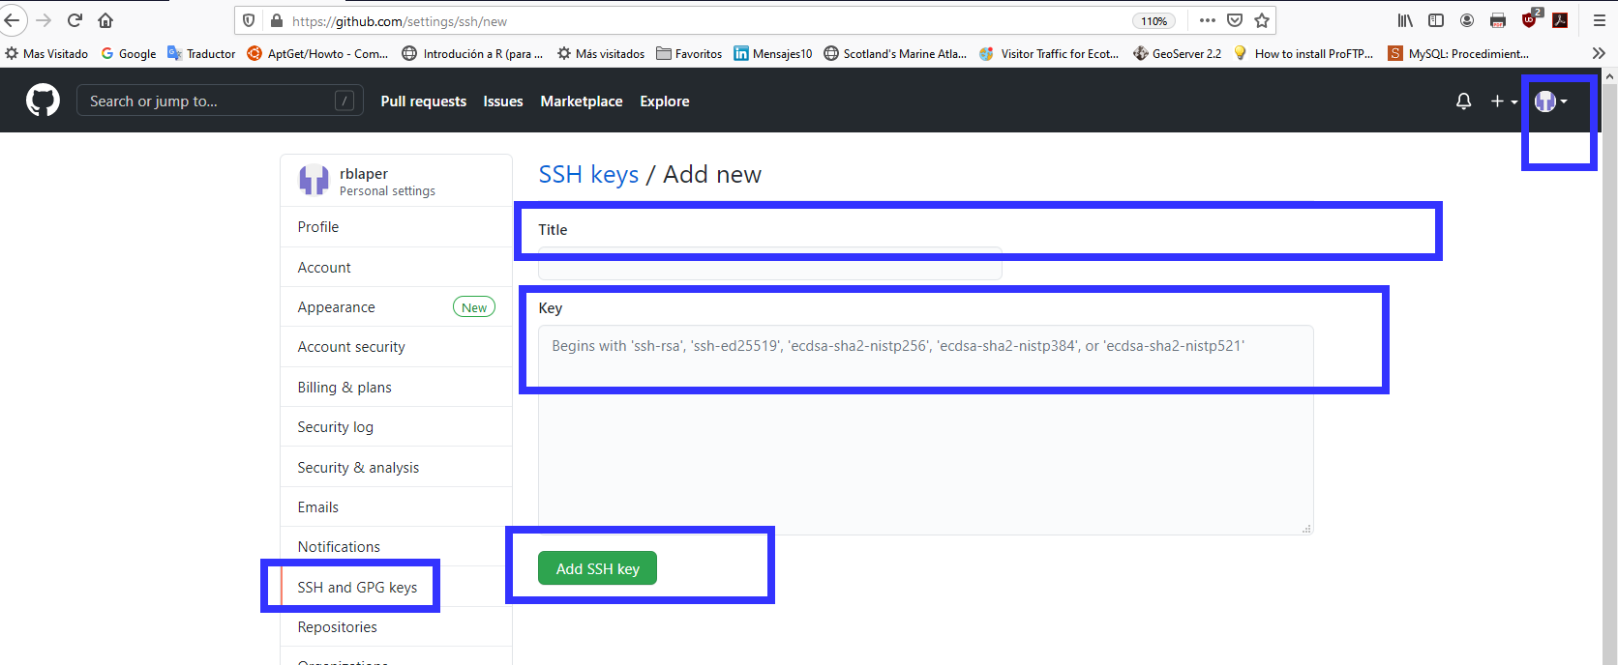

Fill in the **Title** field with a descriptive label for the new key and paste the public key into the **Key** field. Finally, click **Add SSH key**

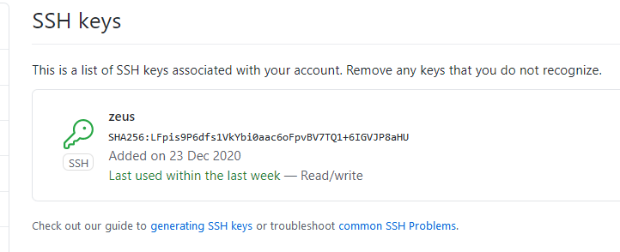

After adding the SSH key to GitHub, test ssh remote access account, open the terminal and run

zeus@zeus-VirtualBox:~/Documents/GitHub/InformationSystems$ ssh -T git@github.com

The authenticity of host 'github.com (140.82.121.3)' can't be established.

RSA key fingerprint is SHA256:nThbg6kXUpJWGl7E1IGOCspRomTxdCARLviKw6E5SY8.

Are you sure you want to continue connecting (yes/no/[fingerprint])? yes

Warning: Permanently added 'github.com,140.82.121.3' (RSA) to the list of known hosts.

Hi rblaper! You've successfully authenticated, but GitHub does not provide shell access.

That command attempts an [SSH remote access](https://kamarada.github.io/en/2018/03/15/how-to-install-opensuse-leap-linux-on-a-server-part-2/) to GitHub. If that is the first time to connect to GitHub via SSH, the SSH client asks if it can trust the public key of the GitHub server.

Although, sometimes when connecting it keep asking for user/password.

So redefine the ssh url for remote origin

zeus@zeus-VirtualBox:~/Documents/GitHub/InformationSystems$ git remote set-url origin [git@github.com:rblaper/InformationSystems.git](mailto:git@github.com:rblaper/InformationSystems.git)

And push the repository and it will no longer ask you to enter the Username and password.

zeus@zeus-VirtualBox:~/Documents/GitHub/InformationSystems$ git push -u origin Unit-1

Warning: Permanently added the RSA host key for IP address '140.82.121.4' to the list of known hosts.

Enumerating objects: 4, done.

Counting objects: 100% (4/4), done.

Compressing objects: 100% (2/2), done.

Writing objects: 100% (3/3), 299 bytes | 99.00 KiB/s, done.

Total 3 (delta 0), reused 0 (delta 0)

remote:

remote: Create a pull request for 'Unit-1' on GitHub by visiting:

remote: https://github.com/rblaper/InformationSystems/pull/new/Unit-1

remote:

To github.com:rblaper/InformationSystems.git

* [new branch] Unit-1 -> Unit-1

Branch 'Unit-1' set up to track remote branch 'Unit-1' from 'origin'.

<https://docs.github.com/en/free-pro-team@latest/github/authenticating-to-github/adding-a-new-ssh-key-to-your-github-account>

<https://kamarada.github.io/en/2019/07/14/using-git-with-ssh-keys/>

<https://levelup.gitconnected.com/how-to-add-ssh-to-github-account-on-linux-1c05c71dacc9>

<https://github.community/t/does-not-provide-shell-access/2728/2>